Mobile Communication System

What is GSM?

- The Global System for Mobile communications is a digital cellular communications system.

- Based on digital technology.

- The standardized system had to meet certain criteria’s:
Spectrum efficiency
International roaming
Low mobile and base stations costs
Good subjective voice quality
Ability to support new services

Network structure
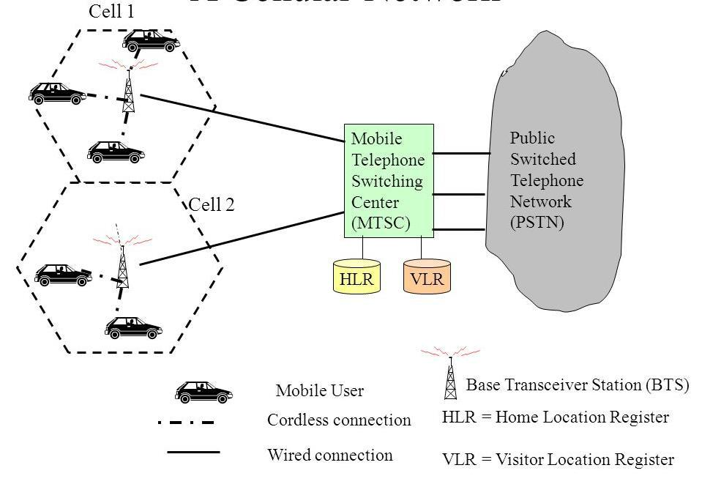

- Cell

- Location area

- MSC service area

- GSM service area

Network Switching Subsystem(NSS)

The system contains the following functional units

- Mobile Switching Center (MSC)

- Home Location Register (HLR)

- Visitor Location Register (VLR)

- Authentication Center (AUC)

- Equipment Identity Register (EIR)

- Operation and maintenance center (OMC)

GSM system architecture

- Mobile Station (MS)

- Base Station Subsystem (BSS)

- Network Switching Subsystem(NSS)

GSM Architecture
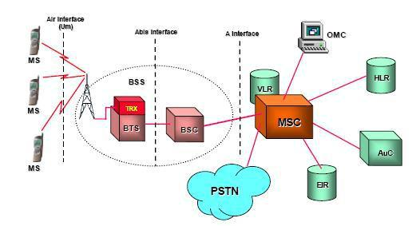

Mobile Station (MS)

- The Mobile Station is made up of two entities:

  - Mobile Equipment (ME)

  - Subscriber Identity Module (SIM)

Mobile Equipment (ME)

- Portable, vehicle mounted, hand held device.

- Uniquely identified by an IMEI (International Mobile Equipment Identity).

- Voice and data transmission.

- Monitoring power and signal quality of surrounding cells for optimum handover. .

Subscriber Identity Module (SIM)

- Smart card contains the International Mobile Subscriber Identity (IMSI)

- Allows user to send and receive calls and receive other subscribed services

- Protected by a password or PIN

- Can be moved from phone to phone – contains key information to activate the phone

Base Station Subsystem (BSS)

It consists of 2 major hardware components:

- Base Transceiver Station (BTS)

- Base Station Controller (BSC)

Base Transceiver Station (BTS)

- The BTS contains the RF components that provide the air interface for a particular cell .

- Encodes, encrypts, multiplexes, modulates and feeds the RF signals to the antenna.

- Communicates with Mobile station and BSC.

- Consists of Transceivers (TRX) units.

Base Station Controller (BSC)

- Provides the control for the BSS.

- Communicates directly with the MSC.

- May control single or multiple BTS.

- In charge of handovers, frequency hopping, exchange functions and control of power level of BTS.

Mobile Switching Center (MSC)

- Central component of NSS.

- MSC performs the switching functions.

- Each MSC provides service to MS located within a defined geographic coverage area.

Home Location Register (HLR)

- Stores information about each subscriber that belongs to its MSC in permanent and temporary fashion.

- As soon as mobile subscriber leaves its current local area, the information in the HLR is updated.

- Database contains IMSI, prepaid/postpaid, roaming restrictions and supplementary services.

Visitor Location Register (VLR)

- The Visitor Location Register (VLR) contains the information about subscriber parameters and location information for all mobile subscribers currently located in the geographical area controlled by that VLR.

- Authentication Center (AUC) It is used for security purposes. Authentication is a process to verify the subscriber SIM. AUC & HLR collectively authenticate the subscribers.

Equipment identity register (EIR)

- Stores all devices identifications registered for this network.
- Database that is used to track handsets using the IMEI.

- White or Valid list
- Grey or Monitored list

- Black or prohibited list Operation and maintenance center (OMC)

- The Operation and maintenance Center (OMC) is the centralized maintenance and diagnostic heart of the base station system (BSS).

- It allows the network provider to operate, administer , and monitor the functioning of the BSS.

What is GPRS ?

- General Packet Radio Service (GPRS) is a new bearer service for GSM that greatly improves and simplifies wireless access to packet data networks,

- GPRS applies packet radio principal to transfer user data packets in an efficient way b/w MS & external packet data network

Benefits of GPRS New Data Services

- High Speed (Data Rate 14.4 – 115 kbps)

- Efficient use of radio bandwith (Statistical Multiplexing)

- Circuit switching & Packet Switching can be used in parallel

- Constant connectivity

Salient Features of GPRS

- Important step on the path to 3GStandardized by

ETSI

- GPRS is an overlay network over the GSM

- Provides Data Packet delivery service

- Support for leading internet communication protocols

- Billing based on volume of data transferred

- Utilizes existing GSM authentication and privacy procedures.

GPRS Services Offers end-to-end packet switched data transfer

- Bearer Services
- PTP - Point-To-Point service (CLNS mode)

- PTM - Point-To-Multipoint service(CONS Mode)
- PTM-M Multicast service

- PTM-G Group call service

- Supplementary Services

- SMS Short Message Service

- CFU Call Forwarding Unconditional
- CFNRc Call Forwarding on mobile subscriber not reachable

- CUG Closed User Group

- Tele action, access to data bases

- Quality of Service

- GPRS allows defining QoS profiles
- Service precedence, reliability, delay, throughput

GPRS SYSTEM ARCHITECTURE
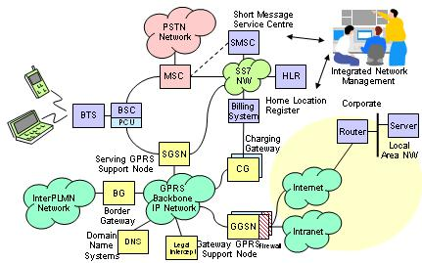

What is GPS?

Global Positioning System (GPS)
- It is a satellite-based navigation system.

- Made up of a network of 24 satellites placed into orbit by the U.S. department of defense.

- GPS was originally intended for military applications, but in the 1980s, the government made the system available for civilian use.

- GPS permits land, sea, and airborne users to determine their three-dimensional position, velocity, and time.

- It can be used by anyone with a receiver anywhere on the planet, at any time of day or night, in any type of weather.

Segments

GPS uses radio transmissions. The satellites transmit timing information and satellite location information. The system can be separated into three parts:

Space segment

Control Segment

User Segment

Space Segment

- The space segment consists of the satellites themselves.

- According to the United state Naval observatory there are currently 27 operational GPS satellites about 11,000 miles up in space.

- This constellation provides between five and eight GPS satellites visible from any point on the earth.

Control Segment

- The control segment is a group of ground stations that monitor and operate the GPS satellites.

- There are monitoring stations spaced around the globe and one Master Control Station located in Colorado Springs

User Segment

- The user requires a GPS receiver in order to receive the transmissions from the satellites.

- The GPS receiver calculates the location based on signals from the satellites

- The users consist of both the military and civilians.

How it works

- GPS satellites circle the earth twice a day in a very precise orbit and transmit signal information to earth.

- GPS receivers take this information and use triangulation to calculate the user's exact location.

- The GPS receiver compares the time a signal was transmitted by a satellite with the time it was received.

- The time difference tells the GPS receiver how far away the satellite is.

- The receiver can determine the user's position and display it on the unit's electronic map.

- A GPS receiver must be locked on to the signal of at least three satellites to calculate a 2D position and track movement four or more satellites in view.

- The receiver can determine the user's 3D position.

Global Positioning System (GPS)
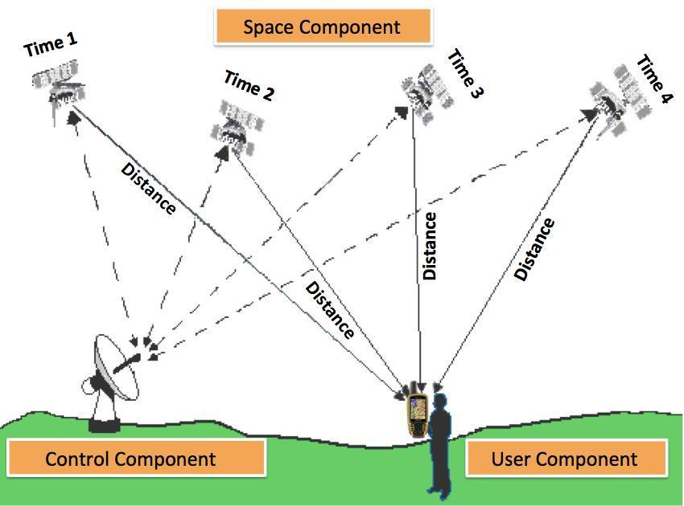

What is the Bluetooth?

- Bluetooth is the wireless technology that connect and transmit voice and data to mobile phones, computers and other devices, and it work without cable.

History of Bluetooth

- In 1994, Ericcson a Swedish company created the Bluetooth Technology

- In 1998, five major companies IBM, Intel, Nokia, Toshiba and Ericsson worked together to connect their product using Bluetooth Special Interest Group (SIG).

Types of Bluetooth

- Bluetooth Dongle.

- Bluetooth Headset.

Bluetooth Dongle

- Installing a Bluetooth dongle is easy; simply insert the CD that came with it, follow the on screen prompts and then plug the dongle into a free USB port.

Bluetooth Headset

- Bluetooth headsets are mainly used with compatible cell phones, place the headset on your ear and roam freely while talking to colleagues, friends and family.

Using Bluetooth

We can use the Bluetooth in
- Cars :
Mobile Phones
GPS navigation
- Home:
Remote Controls
Game controllers

- Medical and Health Devices: Stethoscopes Glucose Monitors

Advantages of the Bluetooth

- Wireless

– Bluetooth works with out cable, it works with wireless.

- Low energy consumption

– Bluetooth uses low power signals. for that reason technology need little energy, and will use less battery.

- Bluetooth Technology is inexpensive

– Bluetooth is cheap to manufacture, and anyone can buy it.

- Sharing voice and data

– The Bluetooth allows to devices to share voice and data communications.

Disadvantages of the Bluetooth

- Data Transfer Rate Bluetooth devices can not be connected with more than one device at the same time, because it finds problem in discovering the another devices.

- Range Bluetooth has a range of 15 to 30 feet. The small range is a disadvantage for some who may want to use a Bluetooth device outside of that 30-foot radius.

- Battery Use Bluetooth uses the battery power of a particular device in order to operate.

- Many cell phone makers send phones out with Bluetooth powered off in order to maximize the battery life of the phone.

